**Name: Sukisivam Balakrishnan  
Superset ID:  6412333  
Exercise 3: Stored Procedures**

**Scenario – 1:**

**Output:**

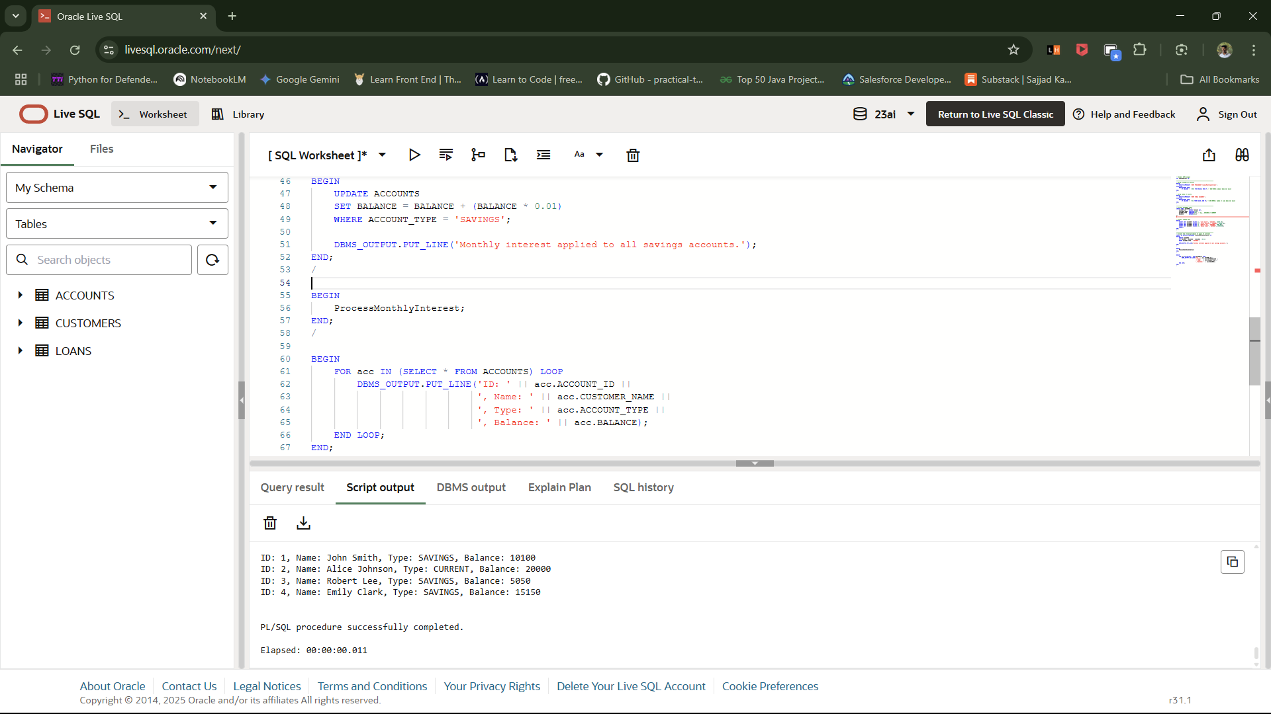

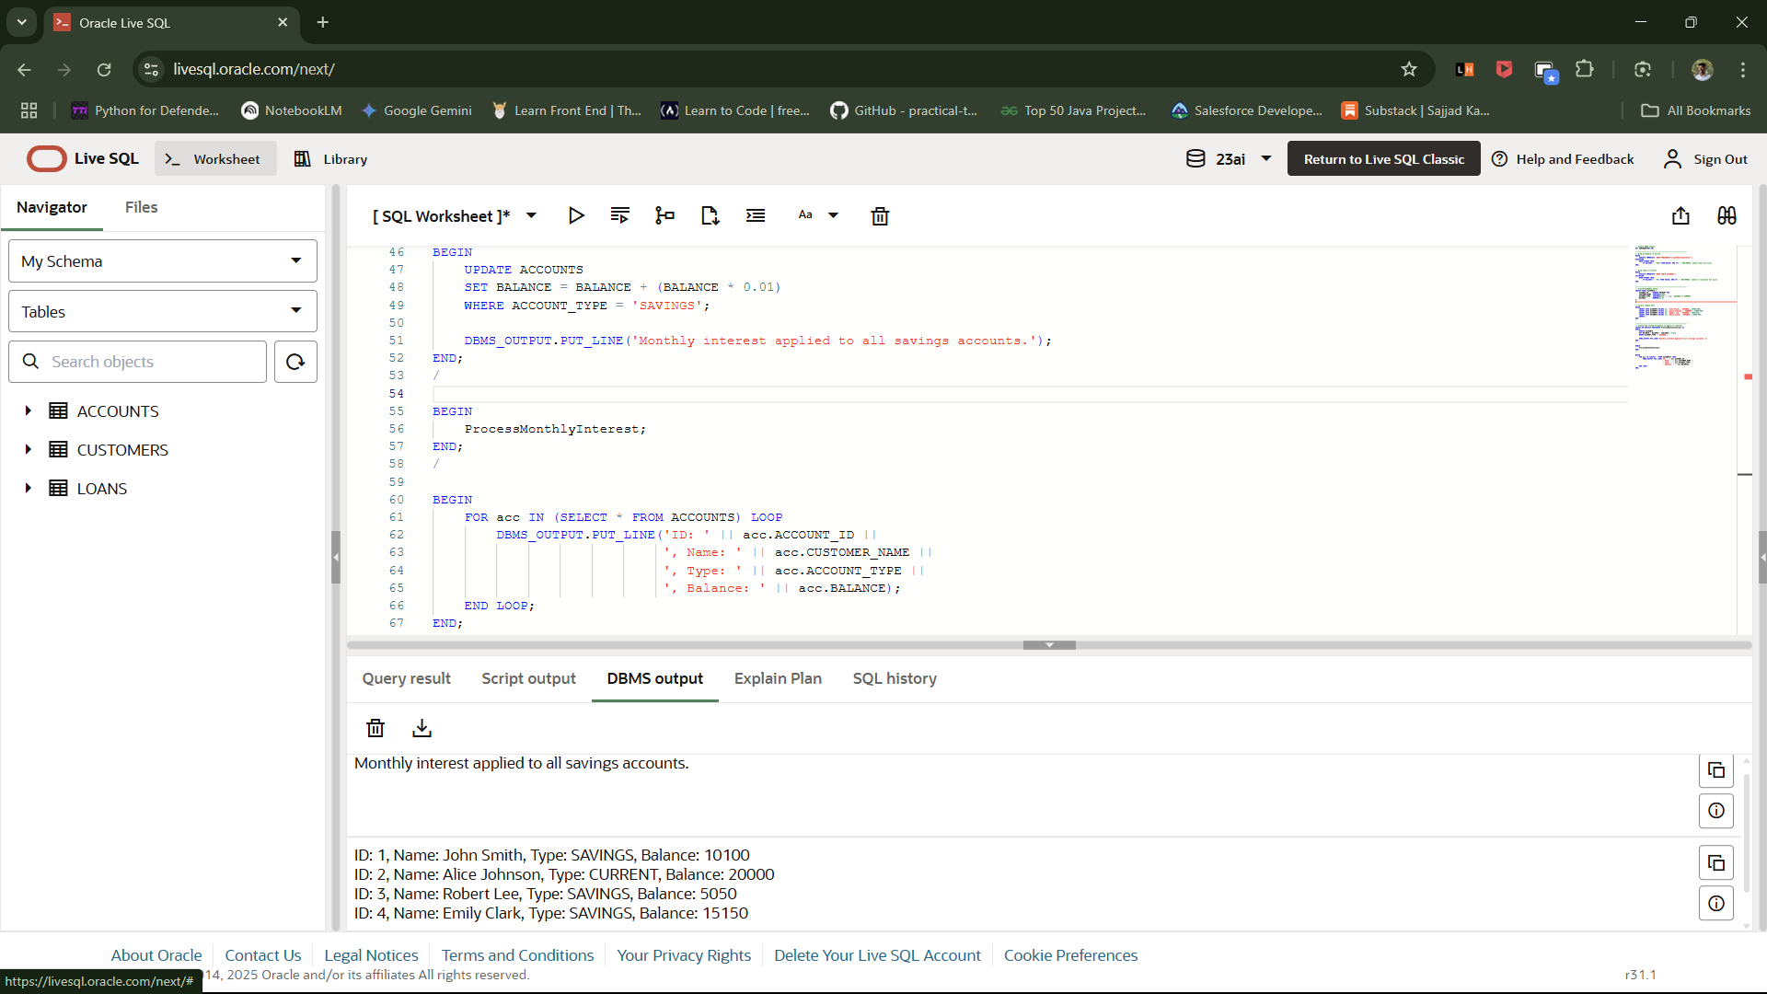

Scenario – 2:

Output:

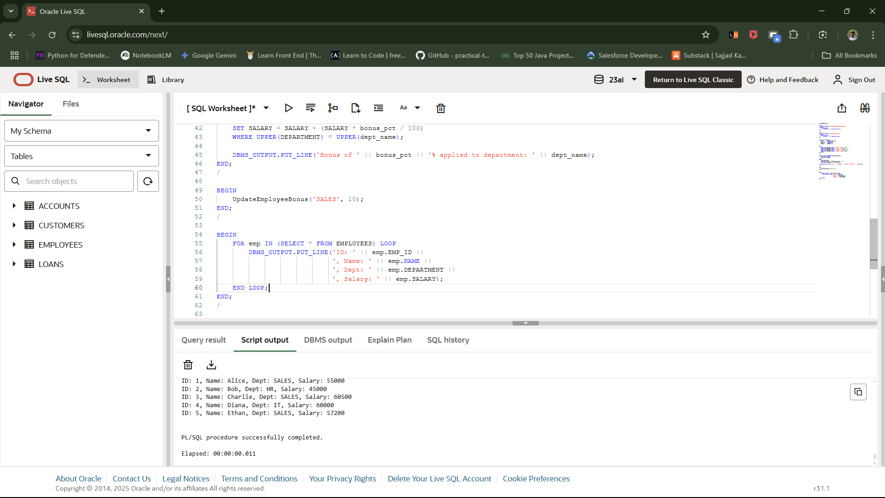

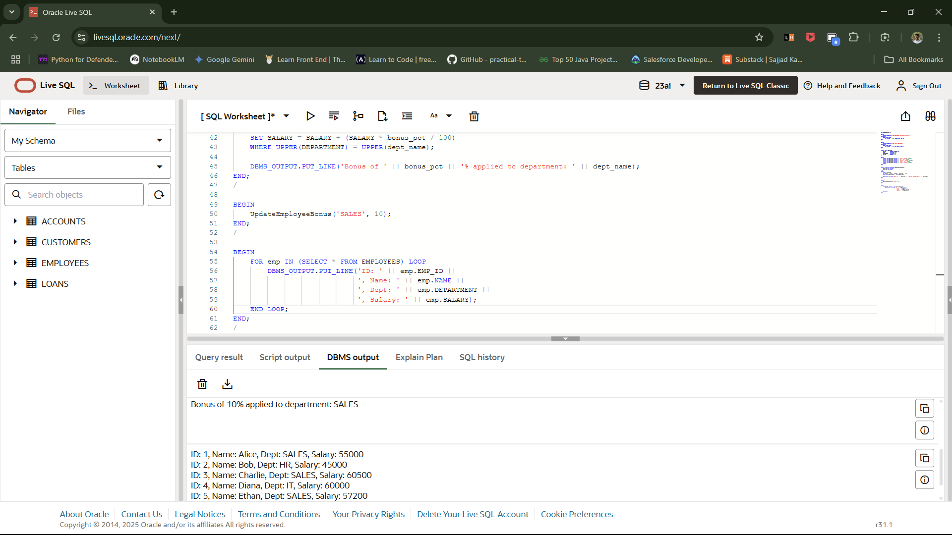

Scenario – 3:

Output:

